Network Design

Examples of Remote In:

SALES

SSH -l admin 10.5.0.129

ISP 2

SSH -l admin 10.5.1.141

SSH -l admin 10.5.1.115

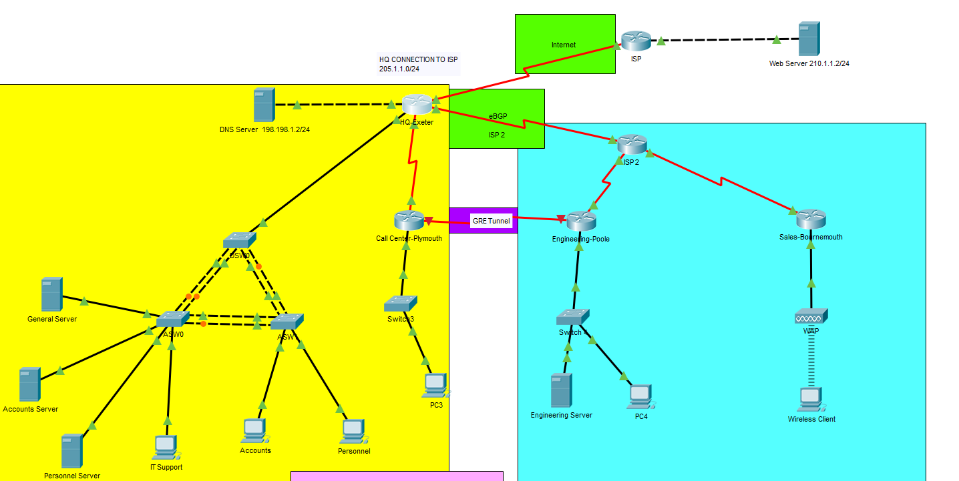

The regional electrical utility company, South West Electrical, needs a network to be designed and implemented. The company supplies electricity over a wide area. Its headquarters is in Exeter with a call-centre in Plymouth connected via leased line. The Engineering division operates out of Poole whilst the Sales team have a Sales Office in Bournemouth. The Bournemouth and Poole branches are connected to the company’s headquarters in Exeter using Frame Relay because of cost considerations. The company’s networks communicate using the open standard routing protocol OSPF.

The company wants to use private addresses throughout for security reasons and DHCP for the LANs. Access to the Internet is provided from Exeter using network address translation. The company also wishes to limit Internet access to Web traffic while allowing multiple protocols within its own WAN. A set of servers are provided at the company’s headquarters in Exeter although the Engineering division has it own server connected to its own network. Due to the size and complexity, the company wants to create VLANs to control broadcasts, enhance security, and logically group users.

Although private addresses (RFC 1918) will be used, the company appreciates efficiency and address conservation in design.

Requirements
The company has 6 departments / divisions – Personnel, Accounts, Engineering, Sales, Customer Services and IT Support. The offsite sales team are provided with wireless laptops for access to the sales network via the Bournemouth branch. Your design must provide for
- 4 employees in the Personnel department.
- 5 employees in the Accounts department.
- 30 employees in the Engineering division at Poole
- 50 wired workstations for Customer Services at Plymouth.
- 50 laptops for external mobile Sales staff for access via Bournemouth office.
- 5 employees (maximum) in IT Support with direct access at Exeter.
- Lifetime max of two servers for Accounts and Personnel and two General Servers for all departments and divisions.
- Expect 100% growth of current IP requirements when determining size of subnets.
- All networking devices must have IP addresses.
- Use VLSM for IP addressing.
- Use subnet 205.1.1.0/24 for connection to the Internet via the HQ router in Exeter.
- There is a DNS server at address 198.198.1.2/24 connected to the HQ router.
- Security between the various networks is required to be controlled via firewalls (access control lists).
- One public address, 199.199.199.1, has been provided external access to the Internet for the company.

Phase 1: Network Design
1. Produce a logical diagram with IPv4 addressing for the based on the scenario given for the WANs and LANs for South West Electrical that includes:

2. The company expects the use of VLSM Design to maximize the use of IP addresses. A table is to be produced showing the subnets that meet the Companies requirements using a VLSM design.
.

Network Name | Number of host addresses | Network Address | Subnet Mask | Gateway Address | 1st/ last
Call-Cntr | 126 | 10.5.0.0 | 255.255.255.128 | 10.5.0.1 | 10.5.0.1-126
Sales | 126 | 10.5.0.128 | 255.255.255.128 | 10.5.0.129 | 10.5.0.129-254
Engineer | 62 | 10.5.1.0 | 255.255.255.192 | 10.5.1.1 | 10.5.1.1-62
Personnel | 14 | 10.5.1.64 | 255.255.255.240 | 10.5.1.65 | 10.5.1.65-78
Accounts | 14 | 10.5.1.80 | 255.255.255.240 | 10.5.1.81 | 10.5.1.81-94
I.T. | 14 | 10.5.1.96 | 255.255.255.240 | 10.5.1.97 | 10.5.1.97-110
MGNT | 14 | 10.5.1.112 | 255.255.255.240 | 10.5.1.113 | 10.5.1.113-126

3. For each device, a set of tables is required. These will assist with design and development activities and used when configuring switches and routers. A separate table should be created for each router and switch.

Router Name: Plymouth PID: CISCO1941/K9 SN: FTX152455IE-
Network Name | Description and Purpose | Interface/Sub Interface Type/Number/ PID | VLAN | Encapsulation | Interface IP Address
CALL LAN | Call Lan | interface GigabitEthernet0/1 | N/A | N/A | 10.5.0.1 255.255.255.128
interface Tunnel0 | GRE tunnel | tunnel source Serial0/0/1 | N/A | N/A | 10.5.1.145 255.255.255.252
PLY WAN TO HQ | PLY WAN TO HQ | interface Serial0/0/1 | N/A | encapsulation ppp | 10.5.1.130 255.255.255.252

Router Name: HQ PID: CISCO1941/K9 SN: FTX152495U4-
Network Name | Description and Purpose | Interface/Sub Interface Type/Number/ PID | VLAN | Encapsulation | Interface IP Address
Personnel | Personnel | GigabitEthernet0/0.10 | VLAN 10 | dot1Q 10 | 10.5.0.1 255.255.255.128
Accounts | Accounts | GigabitEthernet0/0.20 | VLAN 20 | dot1Q 20 | 10.5.1.81 255.255.255.240
I.T. | I.T. | GigabitEthernet0/0.30 | VLAN 30 | dot1Q 30 | 10.5.1.97 255.255.255.240
Mgmt | Mgmt | GigabitEthernet0/0.99 | VLAN 99 | dot1Q 99 native | 10.5.1.113 255.255.255.240
HQ LINK TO DNS | HQ LINK TO DNS | GigabitEthernet0/1 | N/A | N/A | 198.198.1.1 255.255.255.0
Network Name | Description and Purpose | Interface/Sub Interface Type/Number/ PID | VLAN | Encapsulation | Interface IP Address
HQ LINK TO ISP | HQ LINK TO ISP | Serial0/0/0 | N/A | N/A | 205.1.1.1 255.255.255.0
HQ WAN TO PLYMOUTH | HQ WAN TO PLYMOUTH | Serial0/0/1 | N/A | ppp | 10.5.1.129 255.255.255.252
HQ WAN TO ISP 2 | HQ WAN TO ISP 2 | interface Serial0/1/1 | N/A | N/A | 10.5.1.133 255.255.255.252
router bgp 65010 | router bgp 65010 | neighbor 10.5.1.134 remote-as 65003 | N/A | N/A
ip dhcp pool VLAN10 | ip dhcp pool VLAN10 | N/A | N/A | N/A | network 10.5.1.64 255.255.255.240
ip dhcp pool VLAN20 | ip dhcp pool VLAN20 | N/A | N/A | N/A | network 10.5.1.80 255.255.255.240
ip dhcp pool VLAN30 | ip dhcp pool VLAN30 | N/A | N/A | N/A | network 10.5.1.96 255.255.255.240
ip dhcp pool VLAN99 | ip dhcp pool VLAN99 | N/A | N/A | N/A | network 10.5.1.112 255.255.255.240

Router Name: ISP PID: CISCO1941/K9 SN: FTX1524I9EV-
Network Name | Description and Purpose | Interface/Sub Interface Type/Number/ PID | Interface IP Address
ISP LINK TO WEB SERVER | ISP LINK TO WEB SERVER | GigabitEthernet0/1 | 210.1.1.1 255.255.255.0
ISP WAN TO HQ WAN | ISP WAN TO HQ WAN | interface Serial0/0/0 | 205.1.1.2 255.255.255.0

Router Name: ISP 2 PID: CISCO1941/K9 SN: FTX152412IY-
Network Name | Description and Purpose | Interface/Sub Interface Type/Number/ PID | VLAN | Encapsulation | Interface IP Address
ISP WAN TO SALES | ISP WAN TO SALES | interface Serial0/0/1 | N/A | N/A | 10.5.1.141 255.255.255.252
ISP2 WAN TO ENG | ISP2 WAN TO ENG | interface Serial0/1/0 | N/A | N/A | 10.5.1.137 255.255.255.252
ISP 2 WAN TO HQ | ISP 2 WAN TO HQ | interface Serial0/1/1 | N/A | N/A | 10.5.1.134 255.255.255.252
router bgp 65003 | router bgp 65003 | neighbor 10.5.1.133 remote-as 65010 | redistribute ospf 1 | N/A | N/A

Router Name: Engineering-Poole PID: CISCO1941/K9 SN: FTX1524V558-
Network Name | Description and Purpose | Interface/Sub Interface Type/Number/ PID | VLAN | Encapsulation | Interface IP Address
interface Tunnel0 | GRE Tunnel | tunnel source Serial0/1/0 | N/A | N/A | 10.5.1.146 255.255.255.252
POOLE ROUTER | POOLE ROUTER | interface GigabitEthernet0/1 | N/A | N/A | 10.5.1.1 255.255.255.192
ENG WAN TO ISP2 | ENG WAN TO ISP2 | interface Serial0/1/0 | N/A | N/A | 10.5.1.138 255.255.255.252
router bgp 65003 | router bgp 65003 | neighbor 10.5.1.133 remote-as 65010 | redistribute ospf 1 | N/A | N/A

Router Name: Sales-Bournemouth PID: CISCO1941/K9 SN: FTX1524R75T-
Network Name | Description and Purpose | Interface/Sub Interface Type/Number/ PID | VLAN | Encapsulation | Interface IP Address
SALES ROUTER | SALES ROUTER | interface GigabitEthernet0/1 | N/A | N/A | 10.5.0.129 255.255.255.128
SALES WAN TO ISP2 | SALES WAN TO ISP2 | interface Serial0/0/1 | N/A | N/A | 10.5.1.142 255.255.255.252

Wireless Access Point Name:
Interface Type/Port | Description and Purpose | Network Name | Network Number | SSID | Security – WEP key | Interface IP Address or IP range | Subnet Mask
Port 1 (Wireless) | Connect to Wireless Client | SWElectrical | N/A | SWElectrical | 0123456789 | 10.5.0.12-254 | 255.255.255.128

Distribution Switch Name: DSW0 Model: WS-C2960-24TT Base ethernet MAC Address: 0009.7C17.D639
Default-gateway 10.5.1.113 System serial number: FOC1033Z1EY
Port/Number | Description and Purpose | Mac-address | Ip address | VLANs allowed | Switchport Type
interface Vlan10 | Vlan 10 | 0009.7c17.d601 | 10.5.1.66 | 1,10,20,30,99,999 | trunk
interface Vlan20 | Vlan 20 | 0009.7c17.d602 | 10.5.1.82 | 1,10,20,30,99,999 | trunk
interface Vlan30 | Vlan 30 | 0009.7c17.d603 | 10.5.1.98 | 1,10,20,30,99,999 | trunk
interface Vlan99 | Vlan 99 | 0009.7c17.d604 | 10.5.1.114 | 1,10,20,30,99,999 | trunk
Fa0/6-9, Gig0/1 | Vlans allowed on trunk | 1-1005 | Encapsulation  802.1q | 1,10,20,30,99,999 | Native vlan  99

ACCESS Switch Name: ASW0 Model: WS-C2960-24TT Base ethernet MAC Address: 00D0.FF65.4D2D
Default-gateway 10.5.1.113 System serial number : FOC1033Z1EY
Port/Number | Description and Purpose | Mac-address | Ip address | VLANs allowed | Switchport Type
switchport access vlan 30 | Vlan 10/ I.T. PC | 0001.43E8.8947 | 10.5.1.100 | 30 | access
interface Vlan99 | Vlan 99 | 00d0.ff65.4d01 | 10.5.1.116 | 1,10,20,30,99,999 | trunk
Fa0/8-11 | Vlans allowed on trunk | 1-1005 | Encapsulation  802.1q | 1,10,20,30,99,999 | Native vlan  99

ACCESS Switch Name: ASW1 Model: WS-C2960-24TT Base ethernet MAC Address: 0000.0C73.E97D
Default-gateway 10.5.1.113 System serial number: FOC1033Z1EY
Port/Number | Description and Purpose | Mac-address | Ip address | VLANs allowed | Switchport Type
switchport access vlan 20 | Vlan 20/ Acct PC | 00D0.979D.4E89 | 10.5.1.90 | 20 | access
switchport access vlan 10 | Vlan 10/ Per PC | Didn’t show | 10.5.1.74 | 10 | access
interface Vlan30 | Vlan 30 | 0009.7c17.d603 | 10.5.1.98 | 1,10,20,30,99,999 | trunk
interface Vlan99 | Vlan 99 | 0009.7c17.d604 | 10.5.1.114 | 1,10,20,30,99,999 | trunk
Fa0/6-7, Fa0/10-11 | Vlans allowed on trunk | 1-1005 | Encapsulation  802.1q | 1,10,20,30,99,999 | Native vlan  99

Switch 3 Name: ASW1 Model: WS-C2960-24TT Base ethernet MAC Address: 0009.7C29.BD3E
Default-gateway 10.5.0.1 System serial number: FOC1033Z1EY
Switch IP address: 10.5.0.2 255.255.255.128 VLAN: 1

Switch 4 Name: ASW1 Model: WS-C2960-24TT Base ethernet MAC Address: 0001.644C.0E43
Default-gateway 10.5.1.1 System serial number: FOC1033Z1EY
Switch IP address: 10.5.1.2 255.255.255.192 VLAN: 1

For demonstration purposes, the company agrees that it is enough to implement a single representative example of a server for each VLAN and a PC/workstation for each department/division. Stackable switches may be needed to accommodate the requirements for the full implementation.

Services Provided | VLAN | Network Number | Server / PCs | IP address range | Subnet Mask | Gateway
DNS server | N/A | 198.198.1.2 | Server | 198.198.1.2 | 255.255.255.0 | 198.198.1.1
Personnel | 10 | 10.5.1.74 | PC | 10.5.1.64-78 | 255.255.255.240 | 10.5.1.65
General Server | 30 | 10.5.1.101 | Server | 10.5.1.97-110 | 255.255.255.240 | 10.5.1.97
Accounts Server | 20 | 10.5.1.85 | Server | 10.5.1.81-94 | 255.255.255.240 | 10.5.1.81
Personnel Server | 10 | 10.5.1.68 | Server | 10.5.1.64-78 | 255.255.255.240 | 10.5.1.65
I.T. Support | 30 | 10.5.1.100 | PC | 10.5.1.97-110 | 255.255.255.240 | 10.5.1.97
Accounts | 20 | 10.5.1.90 | PC | 10.5.1.81-94 | 255.255.255.240 | 10.5.1.81
PC-3 | 1 | 10.5.0.3 | PC | 10.5.0.1-126 | 255.255.255.128 | 10.5.0.1
PC-4 | 1 | 10.5.1.4 | PC | 10.5.1.1-62 | 255.255.255.192 | 10.5.1.1
Wireless Client | 1 | 10.5.0.131 | PC | 10.5.0.129-254 | 255.255.255.128 | 10.5.0.129
Web Server | N/A | 210.1.1.2 | Server | 210.1.1.2 | 255.255.255.0 | 210.1.1.1

HQ-Configurations-1

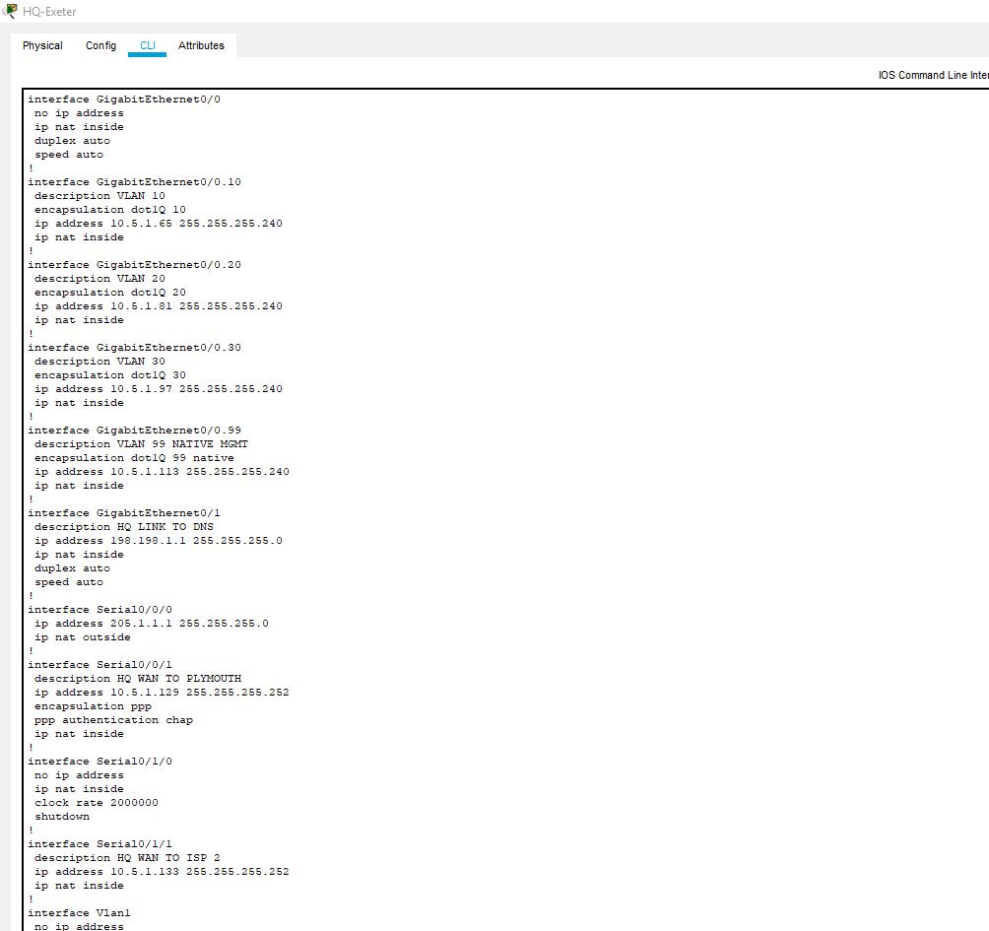

HQ-Exeter-show ip ospf database

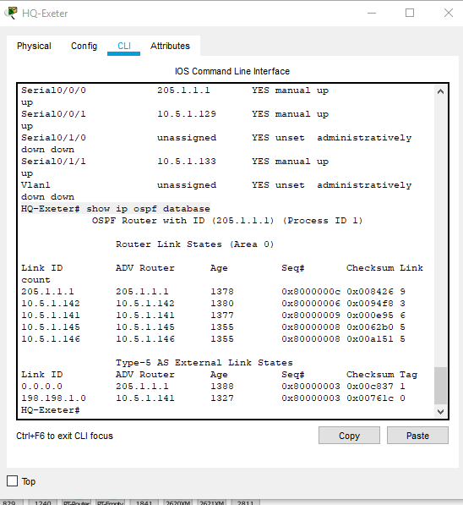

HQ-DHCP Pools Configurations

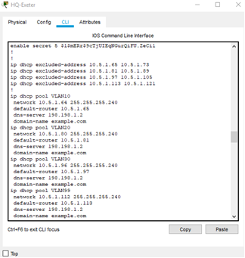

HQ-Exeter-show ip bgp
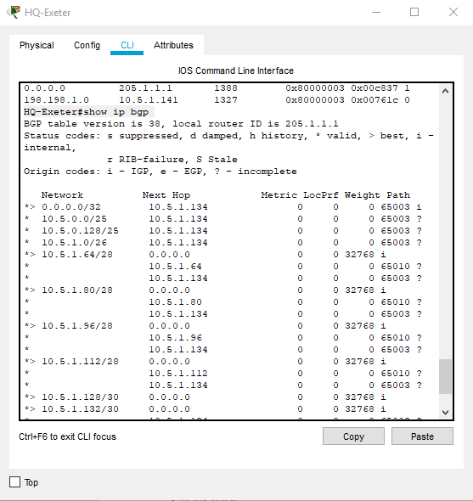

HQ-Exeter#show ip route
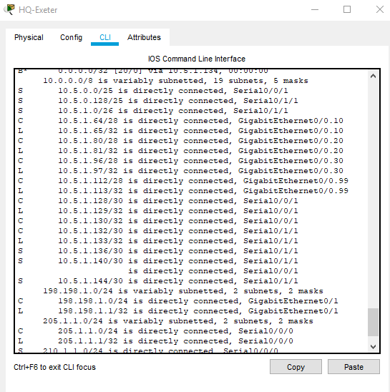

DSW0#show vtp status
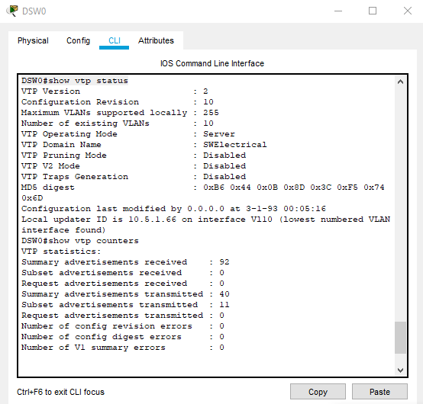

DSW0# show int trunk
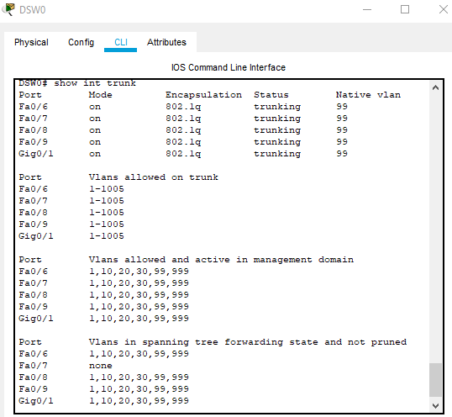

DSW0#show mac address-table
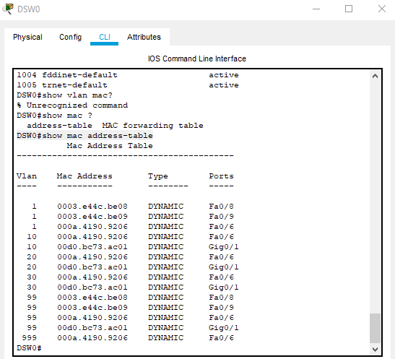

DSW0#show vlan brief
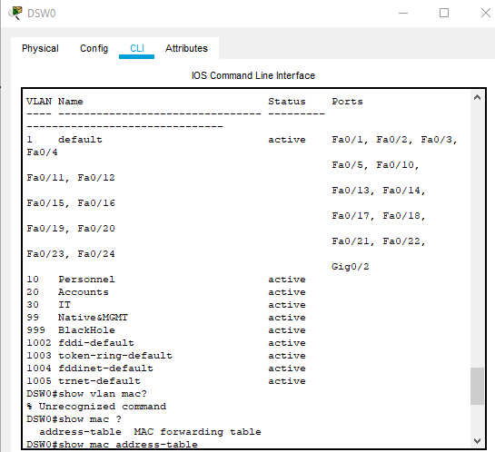

DSW0#show run
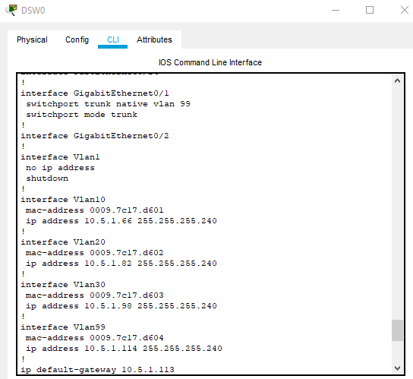

ASW0#show run
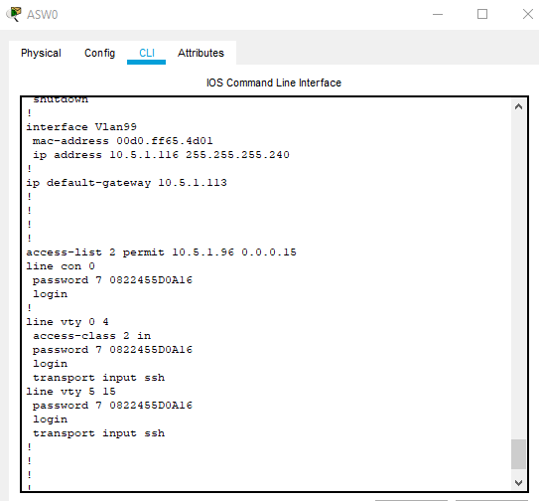

ASW0#show mac address-table
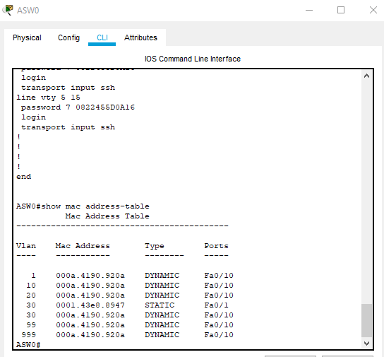
ASW0#show vtp status
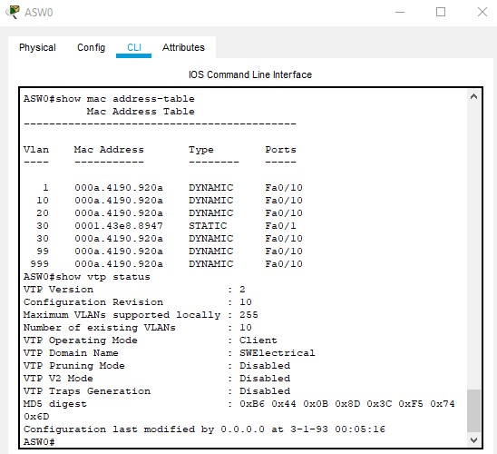

ASW0#show int trunk
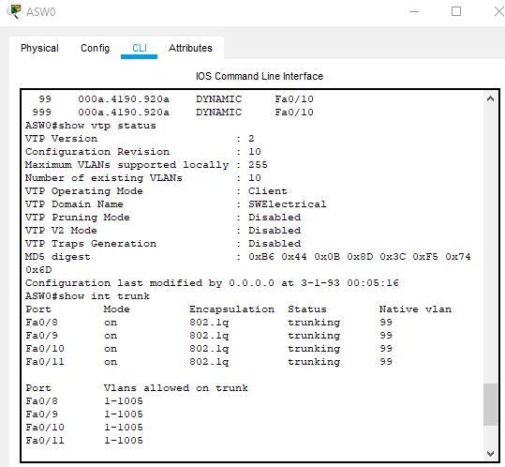

ASW0#show vlan brief
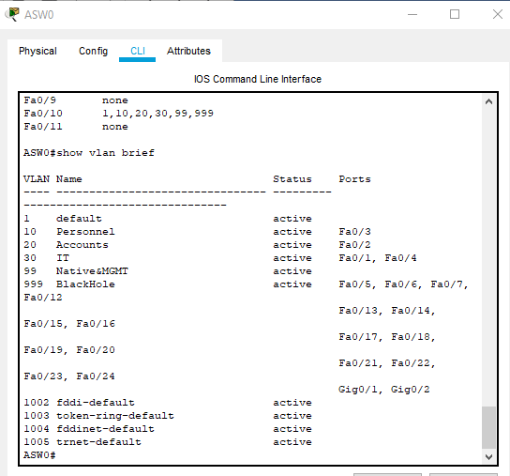

ASW1#show run
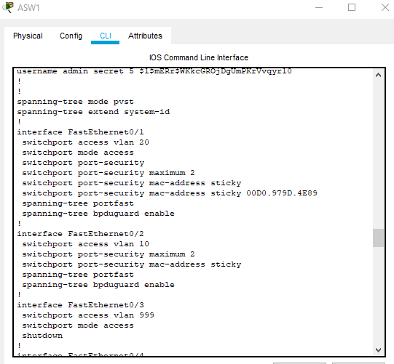
ASW1#show mac address-table

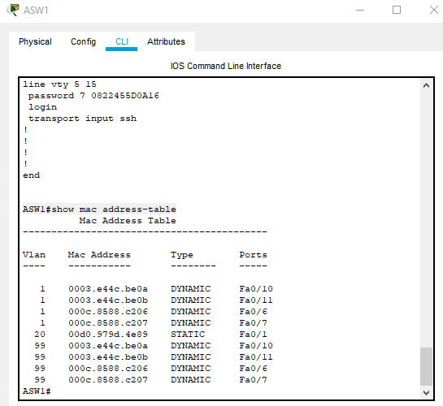

ASW1#show vtp status
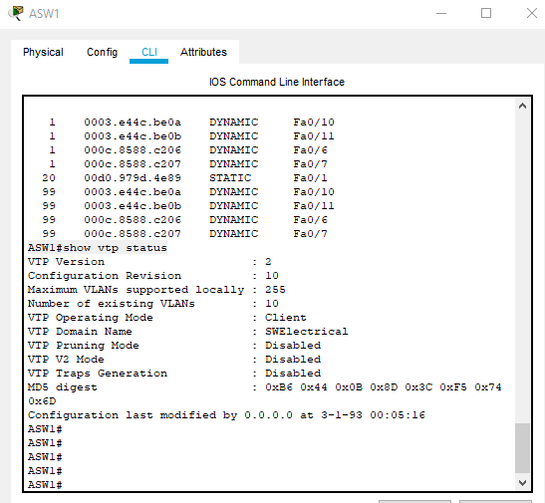
ASW1#show int trunk
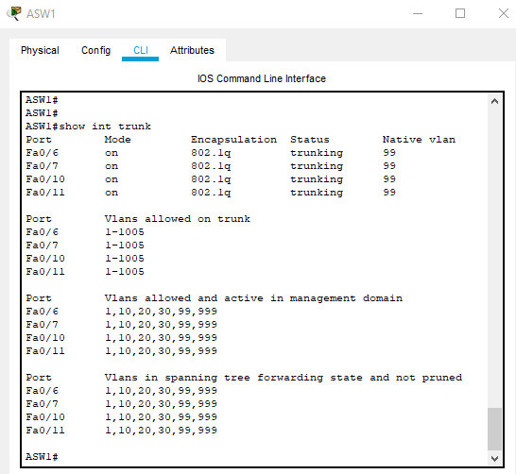

ASW1#show vlan brief
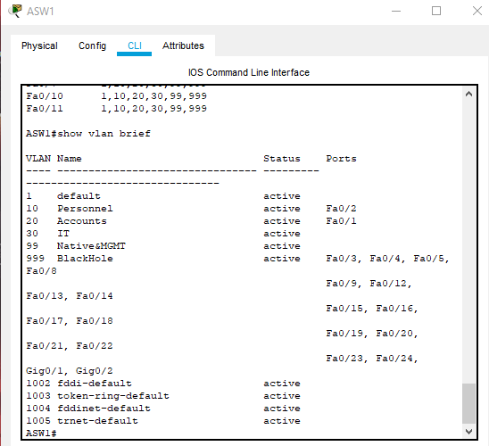

Plymouth#show run
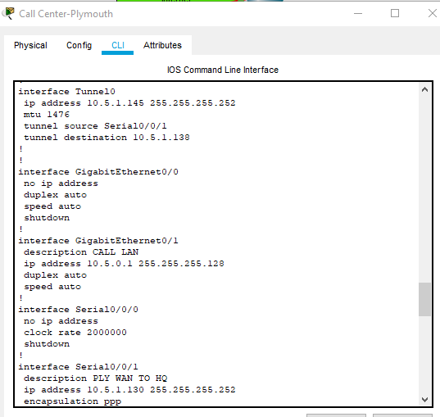

Plymouth#show interface Tunnel0
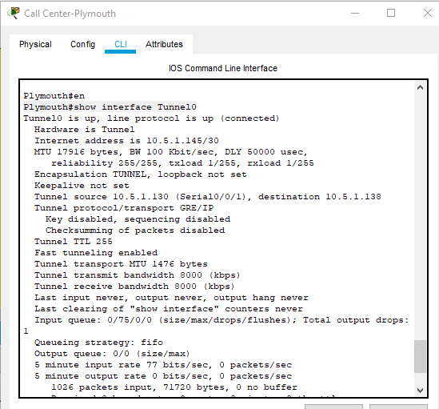
Plymouth#show ip route
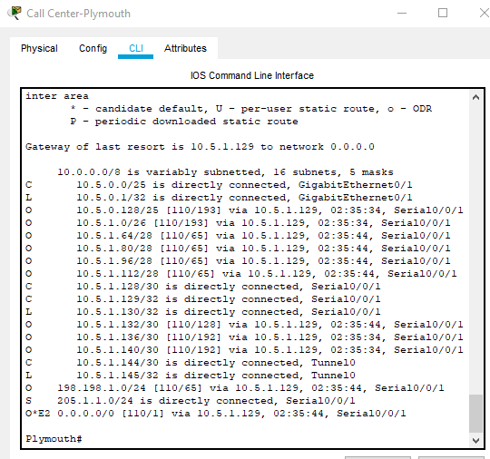

Plymouth#show ip route ospf
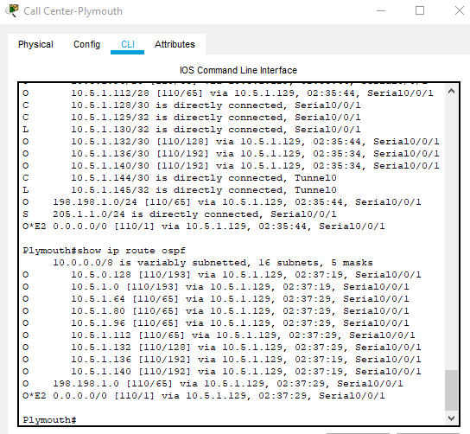
Plymouth#show ip ospf neighbor
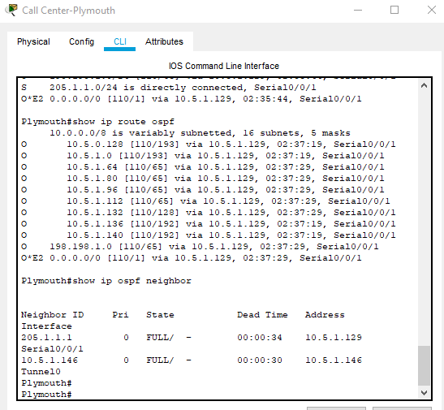

Plymouth#show ip ospf database
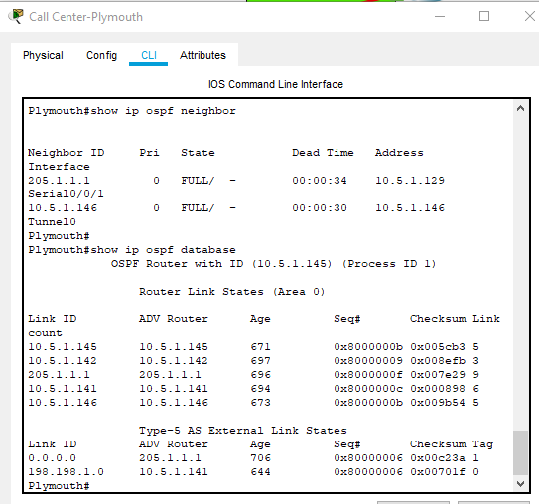
Poole#show run
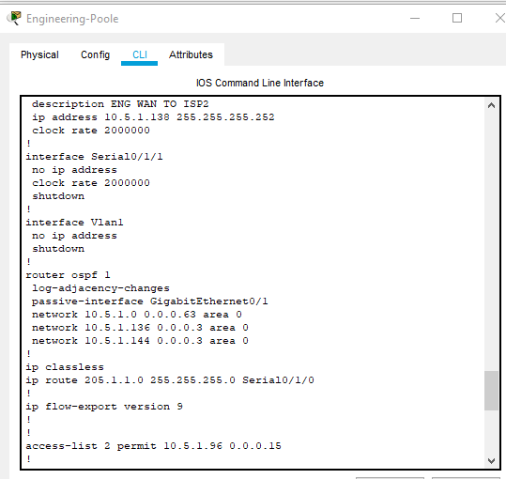

Poole#show interface Tunnel0
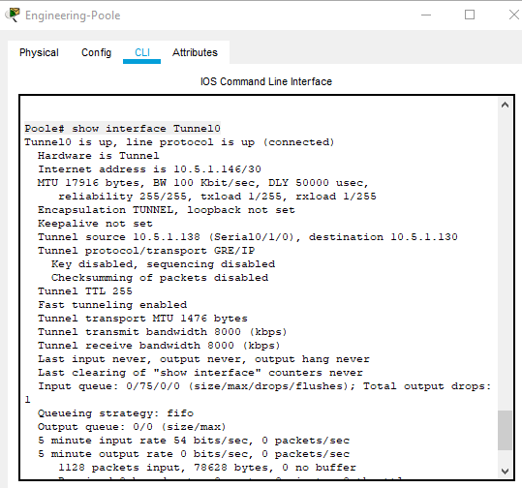
Poole#show ip route
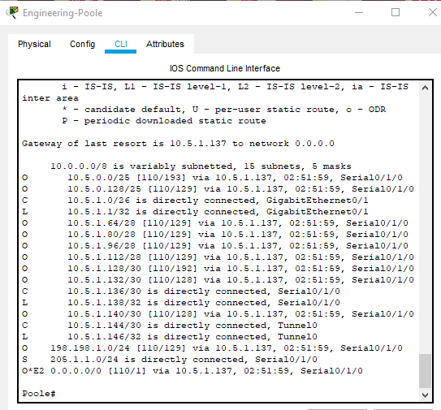

Poole#show ip route ospf
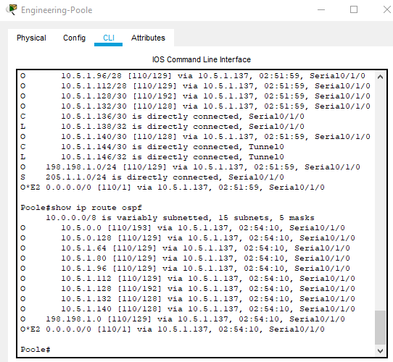
Poole#show ip ospf neighbor
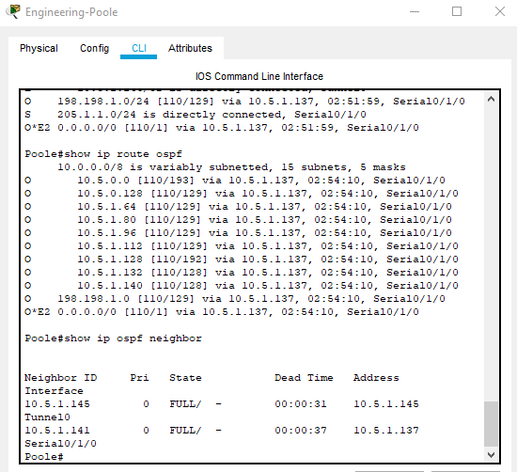

Poole#show ip ospf database
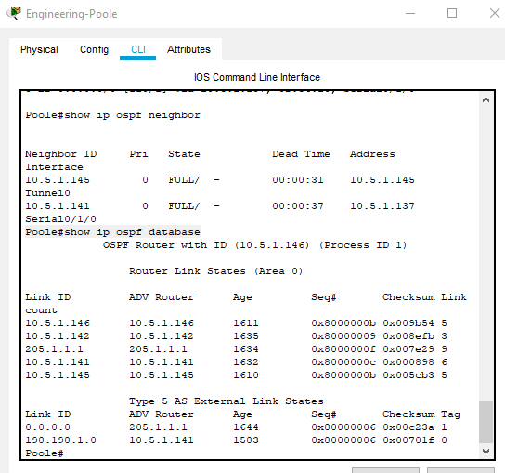
Bournemouth#show run
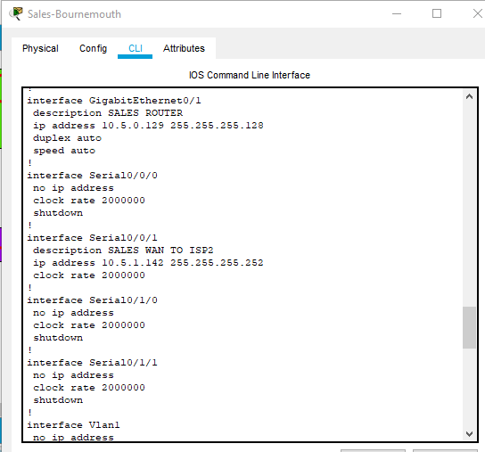

Bournemouth#show ip route
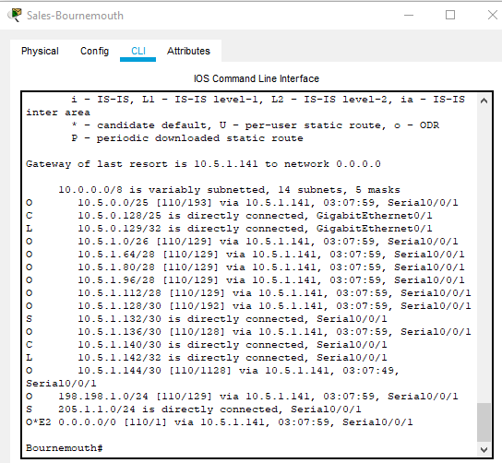
Bournemouth#show ip route ospf
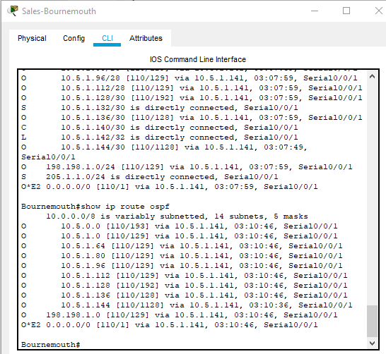

Bournemouth#show ip ospf neighbor
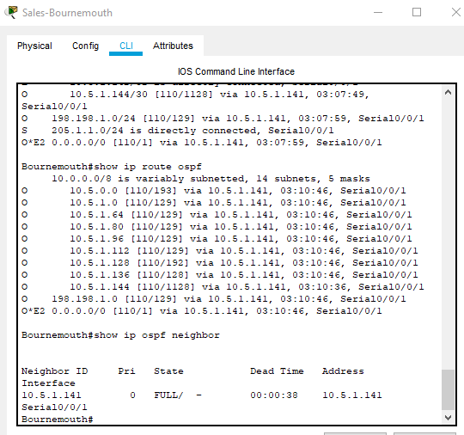
Bournemouth#show ip ospf database
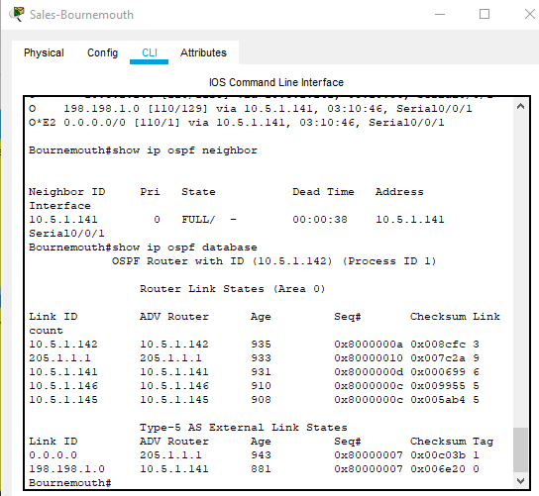

Bournemouth#show ip int brief
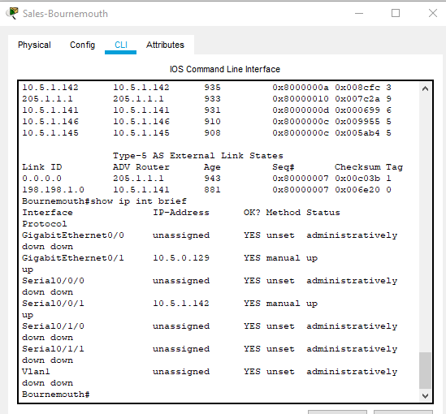
DSW0#ping general server
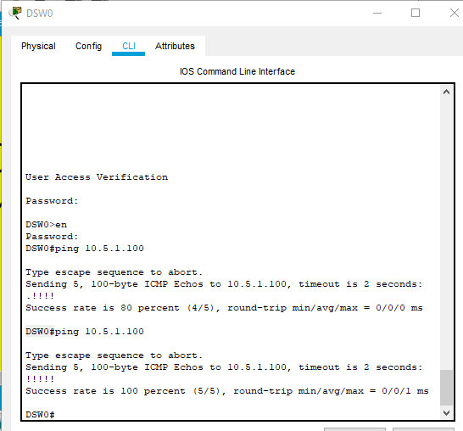

ASW0#ping IT PC
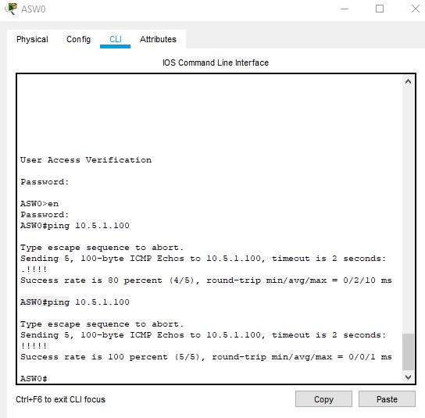
HQ-PING-ASW1
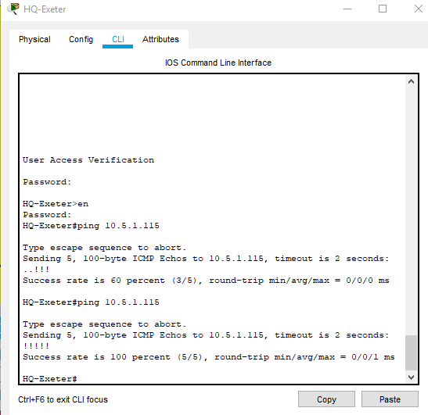

HQ-Exeter#show ip dhcp binding
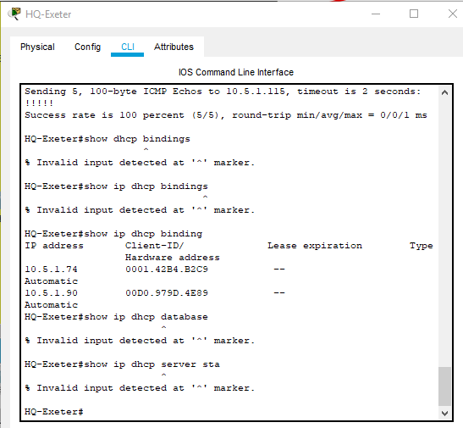
HQ-Exeter#show ip dhcp pool
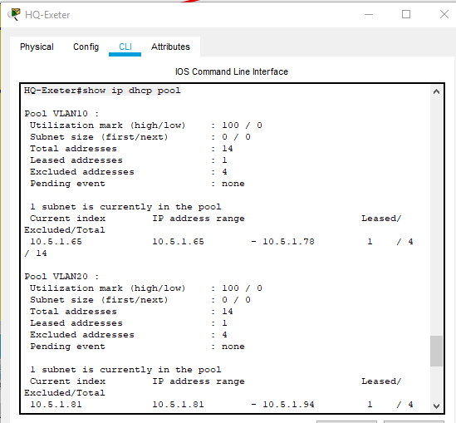

HQ-Exeter#show ip dhcp pool-2
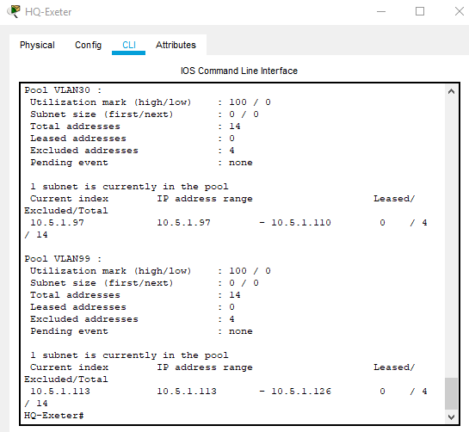
WAP-Security settings
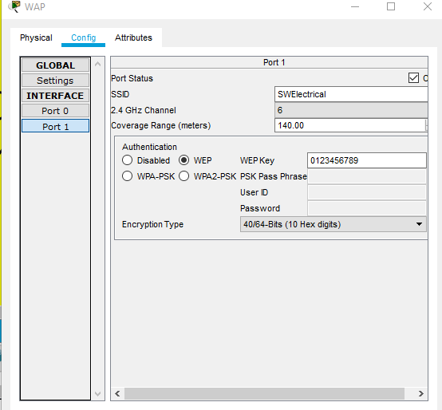

HQ-NAT-Translation
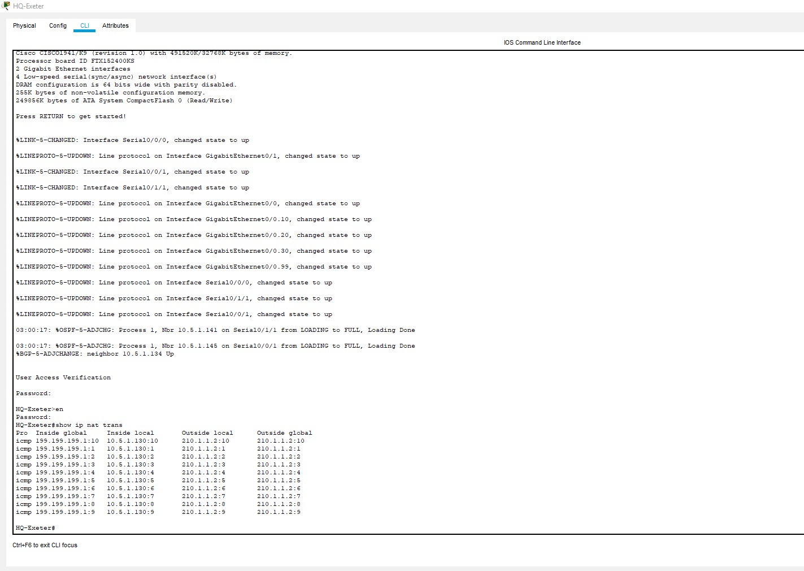
HQ-Exeter#show ip nat stats
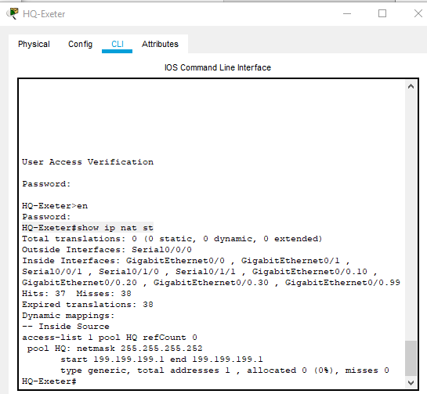

HQ-Exeter#show access-list
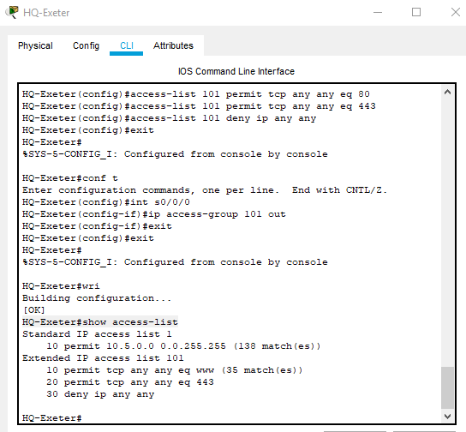

IT-support-http-access
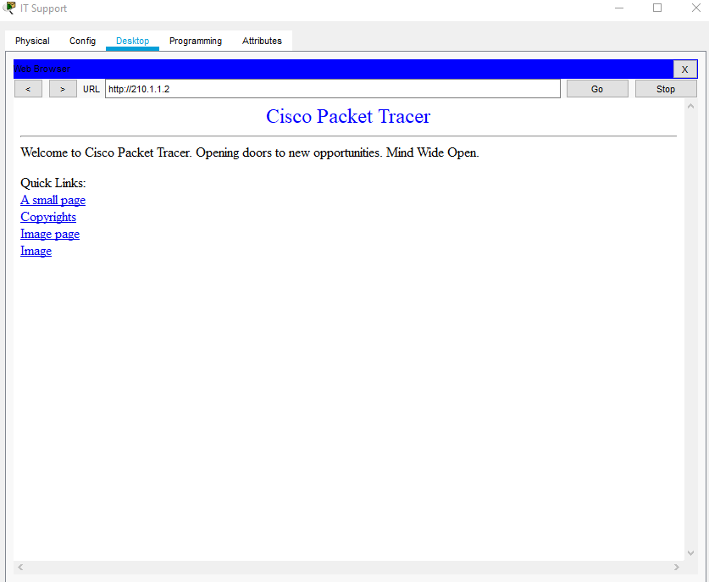

wireless-client-http-access
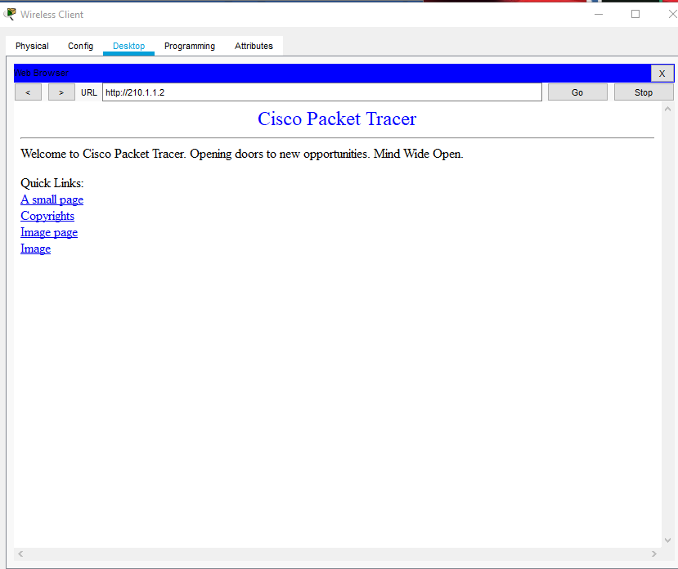
pc-4-http-access
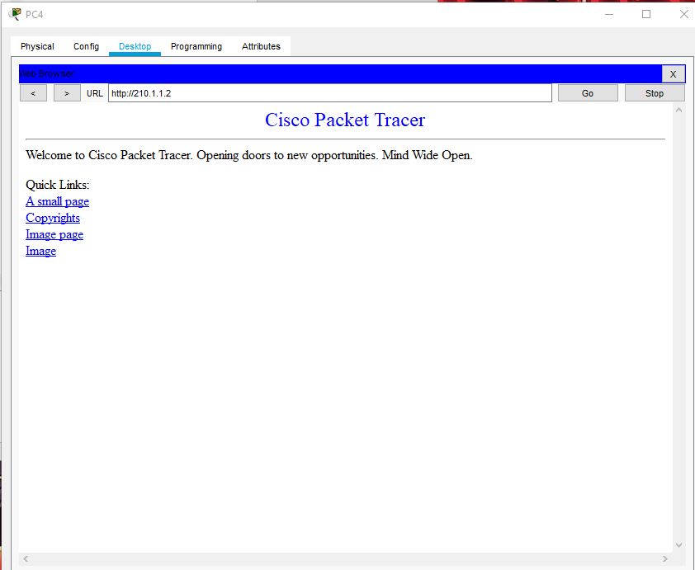

personnel-http-access
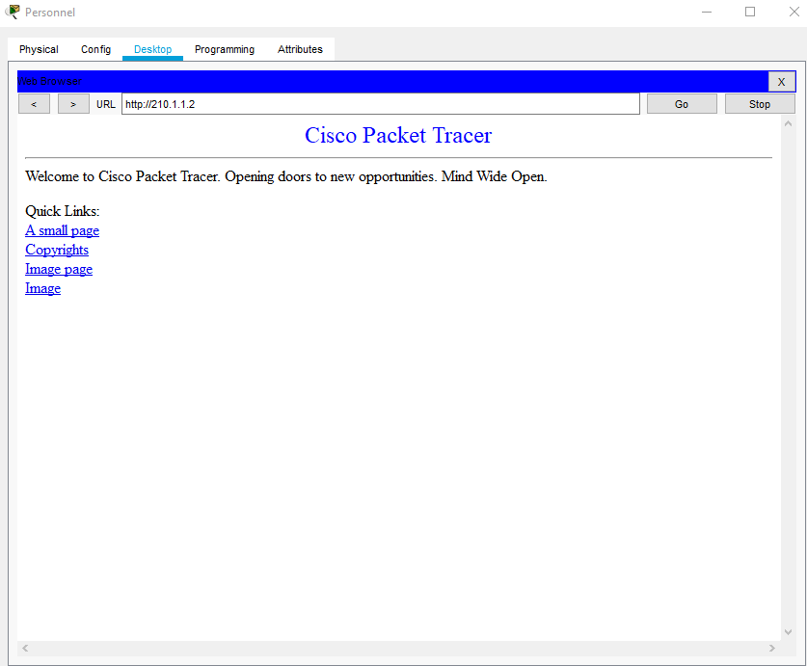
accounts-http-access
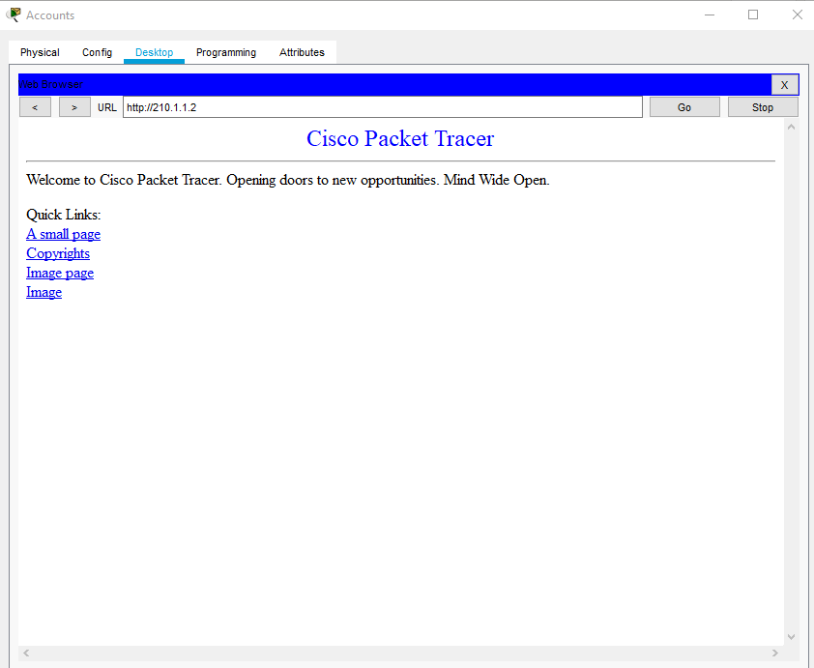

pc3-http-access
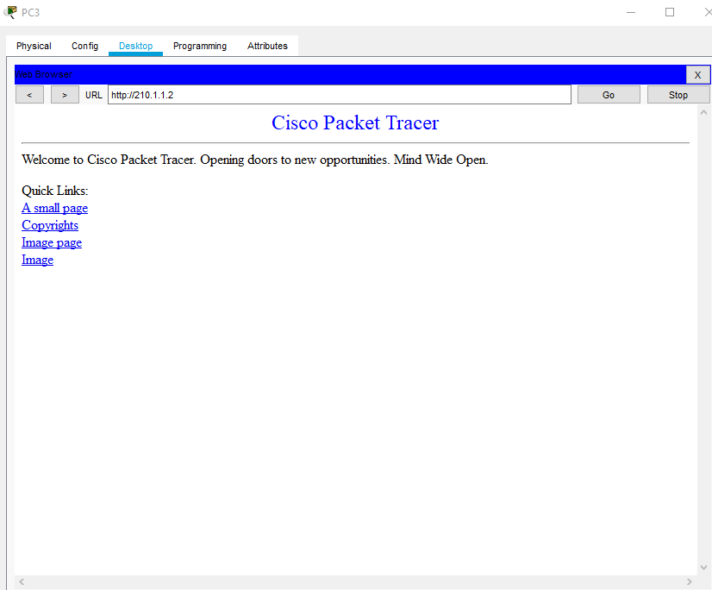
IT-PING-SALES
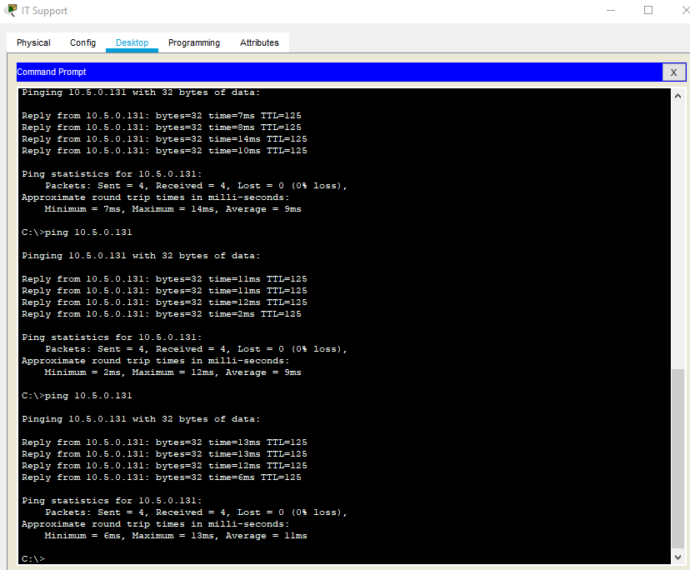

I.T.-PING-Engineering
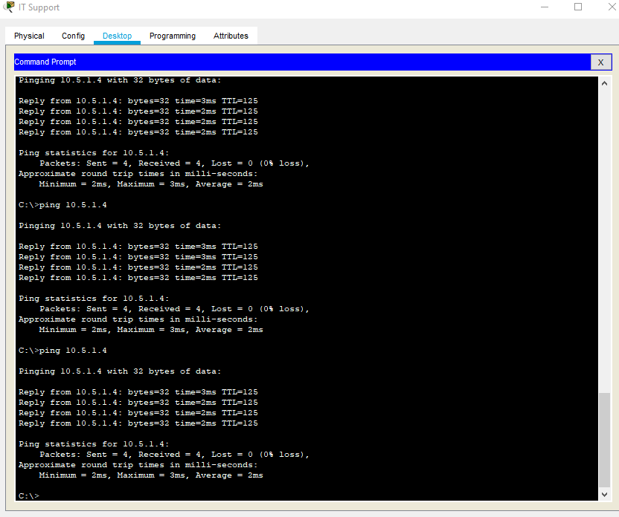
IT-PING-Call-Center
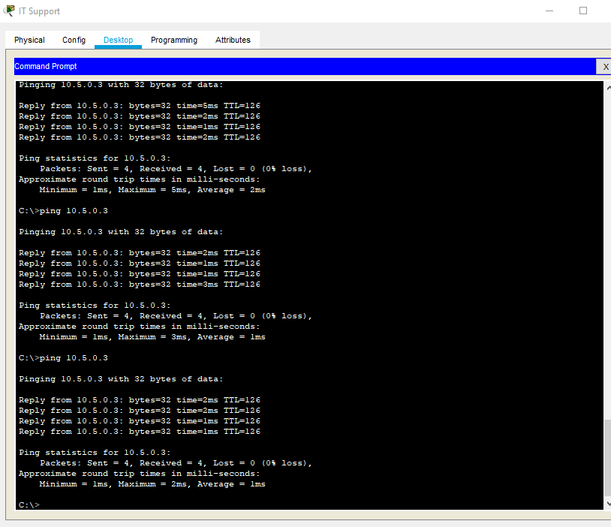

Wireless-client-IT-PING-failure
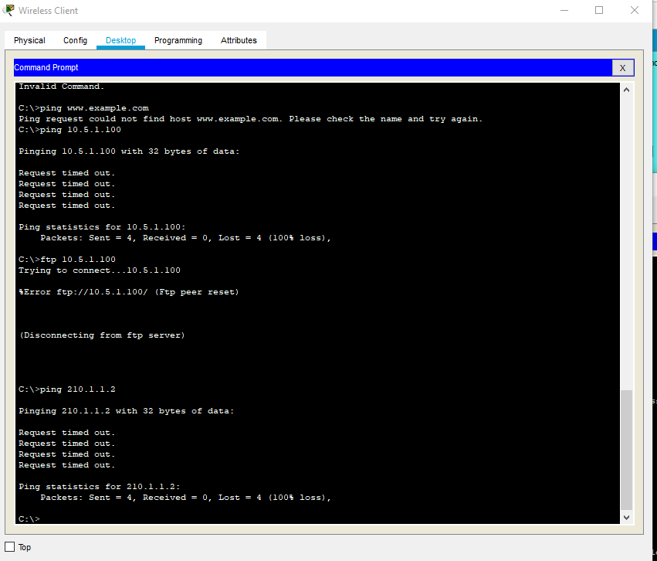
Personnel-IT-PING-failure
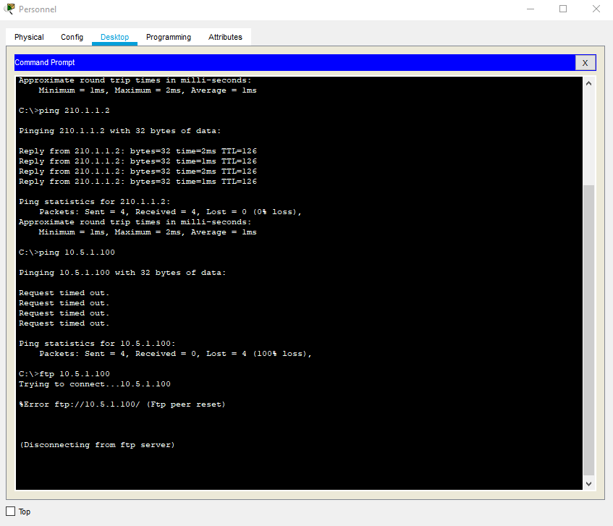

Accounts-IT-PING-failure
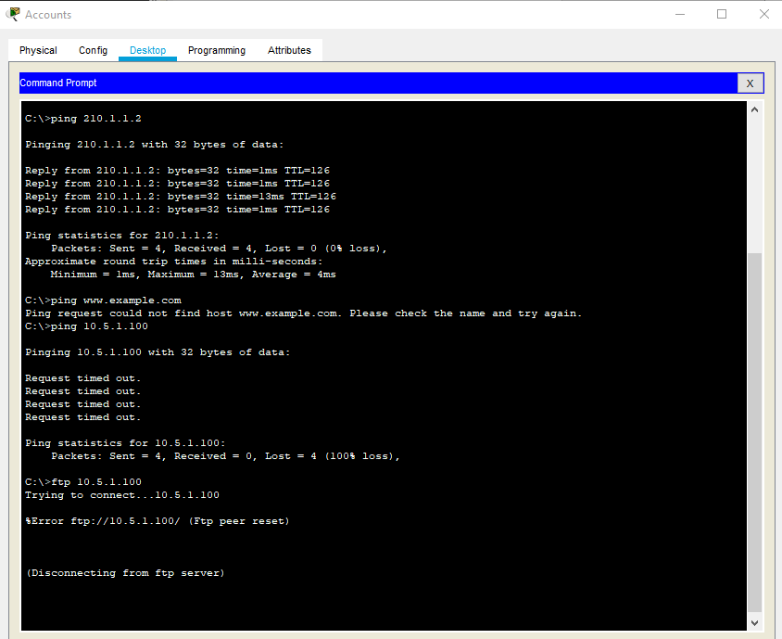
Call-Center-IT-PING-Failure
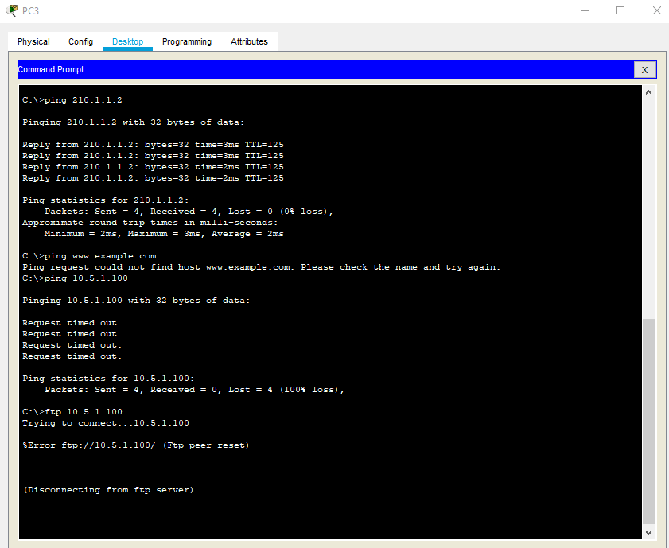

ENG-IT-PING-Failure
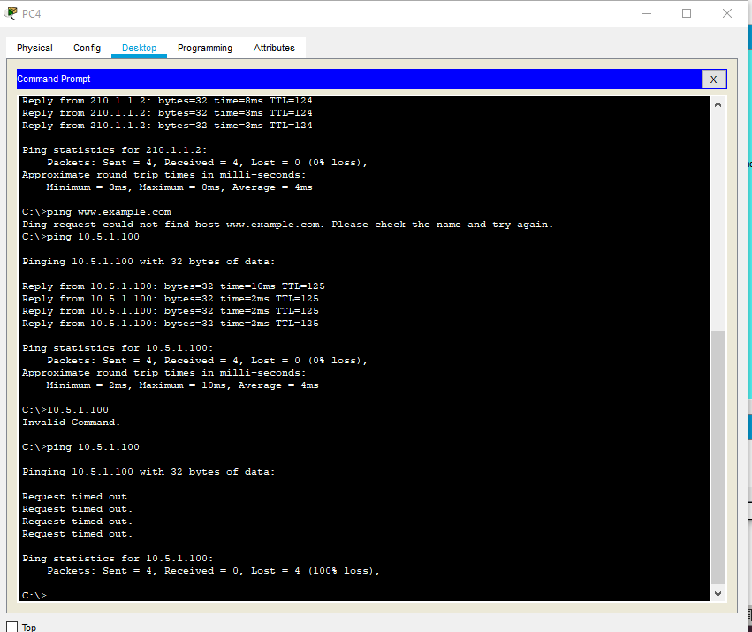
Engineering-ISP-PING-failure
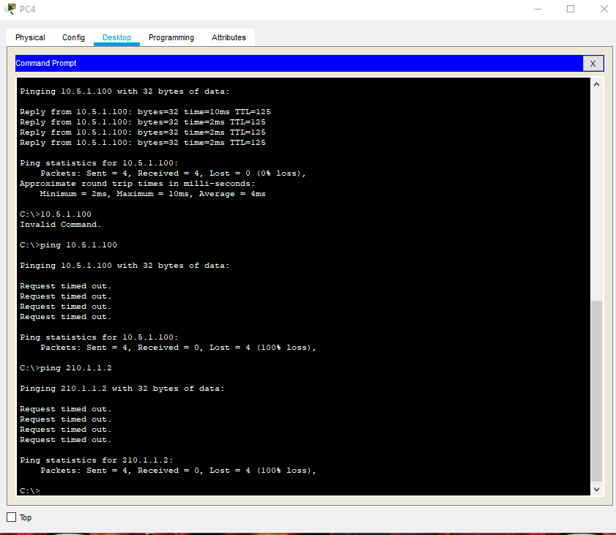

Sales-ISP-PING-Failure
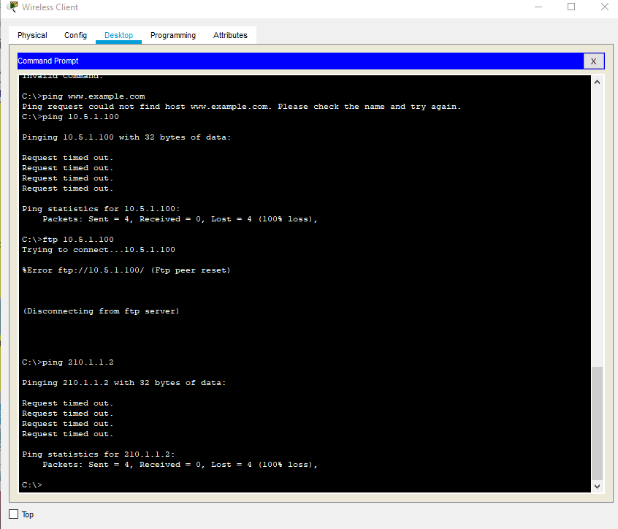
Accounts-ISP-PING-Failure
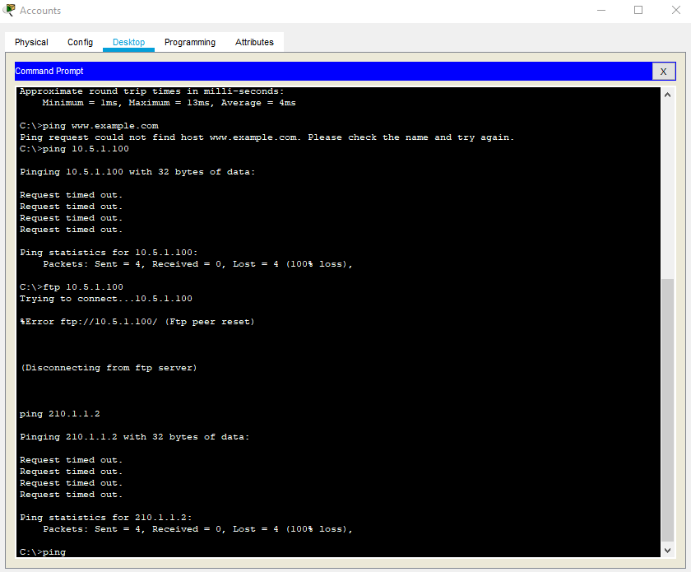

Personnel-ISP-PING-Failure
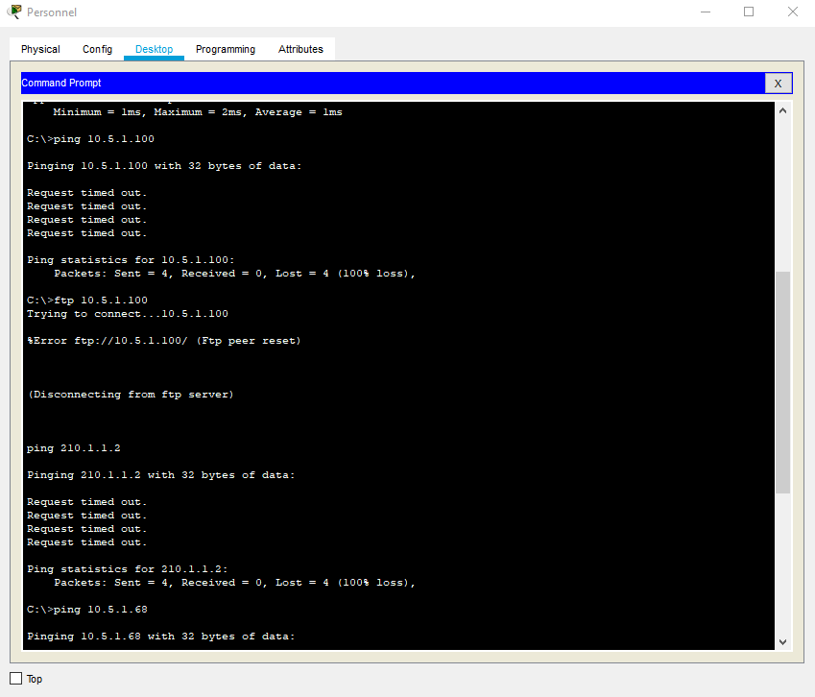

Other snip-its are on PDF File
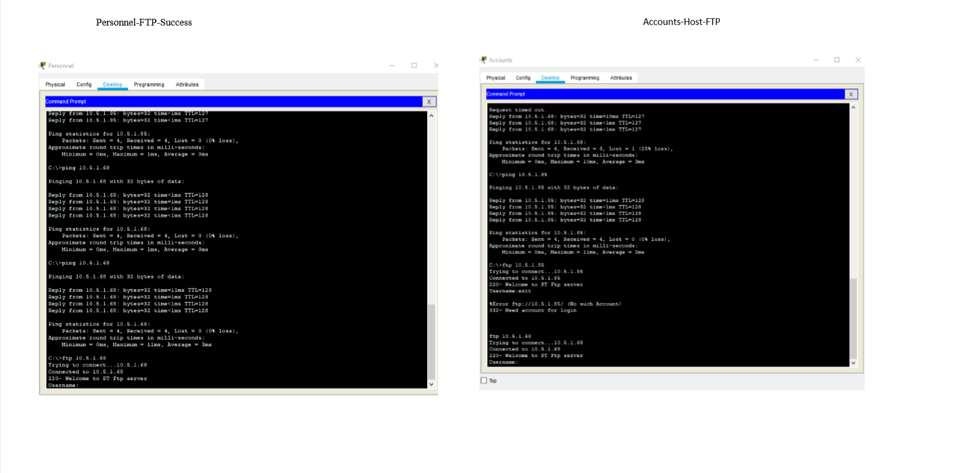




Phase 5: Verification and Testing

Use the following instructions to complete Phase 5:

Verify communication between various hosts in the network. Troubleshoot and fix any problems in the network until it works properly. Document the results of the tests in the table below:
Source | Destination | Protocol | Expected  Result | Signed Date
Host on Sales | example.com | HTTP | Success | 5 Oct 2019
Host on Engineering | example.com | HTTP | Success | 5 Oct 2019
Host on Personnel | example.com | HTTP | Success | 5 Oct 2019
Host on Accounts | example.com | HTTP | Success | 5 Oct 2019
Host on IT support | example.com | HTTP | Success | 5 Oct 2019
Host on IT Support | Host on Sales, Engineering, Personnel, Call Center.  All switches | ping | Success x 5 | 5 Oct 2019
Host on Sales, Engineering, Accounts and Personnel | Host on IT Support | ping | Failure x 4 | 5 Oct 2019
Host on Sales, Engineering, Accounts and Personnel | To Internet | ping, FTP, telnet | Failure x 4 | 5 Oct 2019
Host on Accounts | Accounts server, Personnel Server | FTP or HTTP | Success x 2 | 5 Oct 2019
Host on Personnel | Personnel server | FTP or HTTP | Success | 5 Oct 2019
Host on Engineering | General server | FTP or HTTP | Success | 5 Oct 2019
Host on Accounts | Accounts server | ping | Failure | Successful
Host on Personnel | Personnel server | ping | Failure | Successful
Host on Engineering | General server | ping | Failure | 5 Oct 2019
Host on Sales | General server | ping | Failure | 5 Oct 2019

